University of Newcastle
Cybersecurity Awareness Education and Training Platform
System Analysis and Design
Group: Major Project Group 5
Course: COMP6900 Major Project
Course Coordinator: Dr. Geoffrey Skinner
Due Date: 13 November 2026
Team Members
c3432741 | Turki Almutairi
c3390274 | Ahmad Alharpi
c3506402 | Mohammed Alshehri
c3414514 | Nasser Alhwshany
c3476382 | Yazid Alshawi

Contents
1. Introduction 3
1.1 Problem 3
1.2 What the system does 3
1.3 Training content 3
1.4 Out of scope 4
1.5 Development model 4
2. Requirements 4
2.1 Actors 4
2.2 Use case diagram 5
2.3 Key functional requirements 7
2.4 Non-functional requirements 7
3. Architecture 8
3.1 System context 8
3.2 Layers 10
3.3 Deployment 12
3.4 Class diagram 14
4. Data design 16
4.1 Entity relationship diagram 16
4.2 Tables and constraints 17
4.3 Calculated values 17
4.4 Initial content 17
5. Process design 17
5.1 Trainee state 17
5.2 Two-step login 20
5.3 Daily job 22
5.4 Taking a test 24
5.5 Study assistant 26
6. Interface design 28
6.1 Layout and components 28
6.2 Accessibility 28
7. Implementation 28
7.1 Technology 28
7.2 Code structure 29
8. Testing 29
8.1 Strategy 29
8.2 Traceability 29
8.3 Limitations and next steps 30
References 30

1. Introduction

1.1 Problem
Small and medium enterprises (SMEs) are often the victims of cybercrime, but have little or no security team. The Australian Signals Directorate (ASD, 2025) received over 84,700 cybercrime reports in 2024–25, with the average self-reported loss amounting to $56,600 for a small business and $97,200 for a medium-sized business. Most incidents start with a person: a click on a link, a reused password, an invoice paid to the wrong account. The typical solution is training, but reviews of the field demonstrate that its impact is lost in a matter of months if training is not repeated (Marshall et al., 2024; Prümmer et al., 2024). An SME therefore requires a method to ensure that short modules can be delivered, that what staff learn is tested, that a record of who has taken the training is maintained, and that the staff are reminded when they are due for retraining.

1.2 What the system does
The platform has four types of user:
- An administrator sets up accounts and modules and assigns instructors.
- An instructor writes module pages, builds a question bank, and creates a test by selecting the number of questions it contains; the questions are selected at random from the question bank.
- A trainee reads the pages, takes the test and gets their results.
- A daily job works out who is due for retraining and notifies them by email.

1.3 Training content
For demonstration and testing, the platform ships with four modules built from our group's literature review and from Australian and international guidance (Table 1). There are 6 pages for each module (Introduction, Main risk, Everyday examples, Workplace scenario, Correct decision, Key takeaways). This structure is based on evidence that interactive learning with immediate feedback is more effective than passive reading (Marshall et al., 2024) and NIST's guidance that awareness content should change what people do at their desk (National Institute of Standards and Technology [NIST], 2024a).
Table 1
Seeded training modules
Module | Main behaviour taught | Guidance it rests on
1. Social Engineering and Phishing | Spot urgency, authority and familiarity lures; verify a supplier's bank change by phone | ACSC phishing advice; ISO/IEC 27002 6.3, 6.8
2. Password and Account Security | Passphrases, MFA, rejecting unexpected MFA prompts | Essential Eight (MFA); ISO/IEC 27002 5.17, 8.5
3. Data Security and Privacy | Classify, share minimally, clear desk, report breaches | NIST CSF 2.0 PR.DS; ISO/IEC 27002 5.12, 5.34
4. Safe Network and Device Use | Patch, avoid open Wi-Fi, back up, report lost devices | Essential Eight (patching, backups); ISO/IEC 27002 8.1, 6.7
Control numbers are from the Australian Cyber Security Centre's (ACSC) phishing guidance (ACSC, n.d.), the Essential Eight (ASD, n.d.), ISO/IEC 27002:2022 (International Organization for Standardization [ISO], 2022) and NIST CSF 2.0 (NIST, 2024b).

1.4 Out of scope
Self-registration, forums and messaging, SCORM/xAPI import, notification preferences, multiple organisations in one installation and certificates are not included. If there is no multi-tenancy, an IT provider that supports multiple SMEs will need one installation for each client.

1.5 Development model
The project is presented as a waterfall: requirements (Section 2), design (Sections 3 to 6), implementation (Section 7) and testing (Section 8). The build was actually incremental. Requirements were grouped and delivered in order: P0 accounts, two-step login and roles; P1 modules, pages and registration; P2 question bank, tests and scoring; P3 progress and dashboards; P4 retake scheduling and notifications. This is plan-driven incremental delivery (Sommerville, 2016) and even Royce (1970), generally credited with the waterfall, said that one pass without feedback is risky. Fixed requirements are best suited to a strictly sequential model. As the design developed, our requirements expanded, so building in priority order meant that each group of features worked before the next one depended on it.

2. Requirements

2.1 Actors
Table 2
Actors
Actor | Description
Administrator | Creates accounts and modules, publishes modules, assigns instructors
Instructor | Manages content, tests and results for the modules they are assigned to
Trainee | Reads content, takes tests, views progress
Scheduler | Automatic daily process that sends due and overdue notices
A user's role on a module (registration.role_in_module) is separate from their platform role, so one person can teach one module and be a trainee on another.

2.2 Use case diagram
The use cases within the system boundary are depicted in Figure 1. Reading pages, taking a test and asking the study assistant each include a module access check, which is enforced once in a service rather than repeated on each screen (Dennis et al., 2015).

Figure 1
Use case diagram
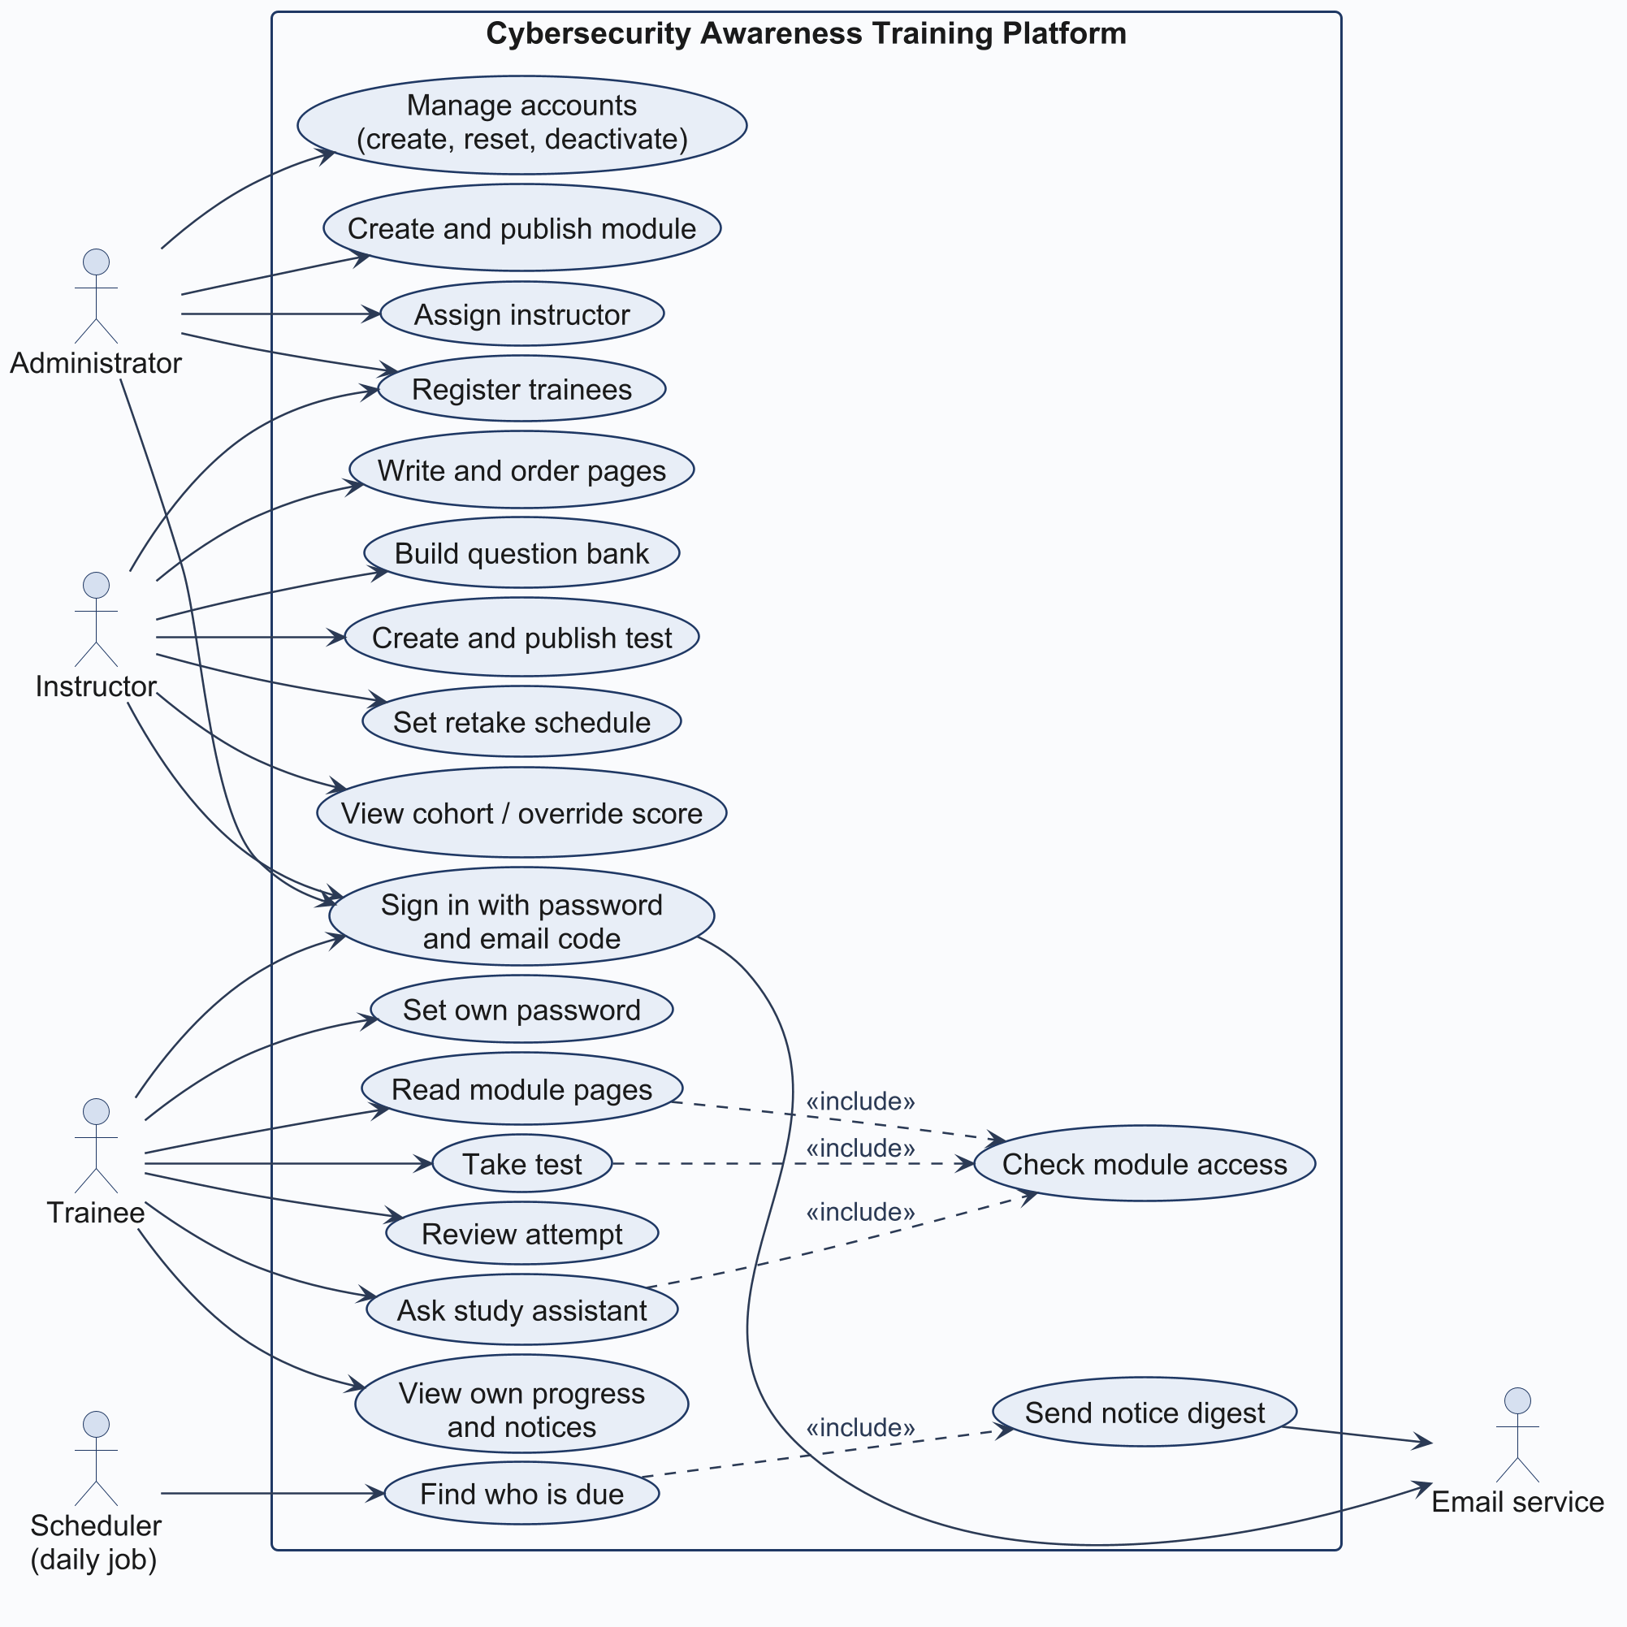

2.3 Key functional requirements
Table 3
Key functional requirements
ID | Requirement | Rationale
FR1 | Only an administrator creates accounts | No self-registration, so no fake accounts
FR2 | Login needs a password and a 6-digit emailed code | Second factor against stolen passwords
FR3 | New accounts set their own password first | Administrators never know a user's password
FR4 | Deactivation takes effect on the next request | Leavers lose access immediately
FR5 | Only assigned instructors edit a module | Least privilege (OWASP Foundation, 2021)
FR6 | A test with attempts cannot be edited | Scores stay comparable
FR7 | Time limits are enforced on the server; an expired attempt is submitted on next load | Client clocks cannot be trusted
FR8 | The latest attempt decides the result | Result reflects current knowledge
FR9 | Results and due dates are calculated, not stored | No stale or conflicting values
FR10 | A new trainee gets a full interval from registration | Fair start for late joiners
FR11 | An overdue notice is sent once; running the job twice creates no duplicates | Avoids alert fatigue (Reeves et al., 2021)

2.4 Non-functional requirements
Table 4
Non-functional requirements
Attribute | Requirement
Deployment | Runs with docker compose up (three containers)
Offline assets | Bootstrap, icons, fonts, htmx and Quill served locally
Accessibility | WCAG 2.2 AA text contrast (W3C, 2023)
Responsive | Works on phone, tablet and desktop
Data integrity | Unique constraints enforced by the database
Security | Argon2 password hashing, CSRF tokens, rate limiting
Two gaps remain: there is no performance target (for example, response time with 200 concurrent trainees) and no availability target.

3. Architecture

3.1 System context
Figure 2 shows the platform's users and its two external services: Brevo for email and, optionally, Google Gemini.

Figure 2
System context diagram
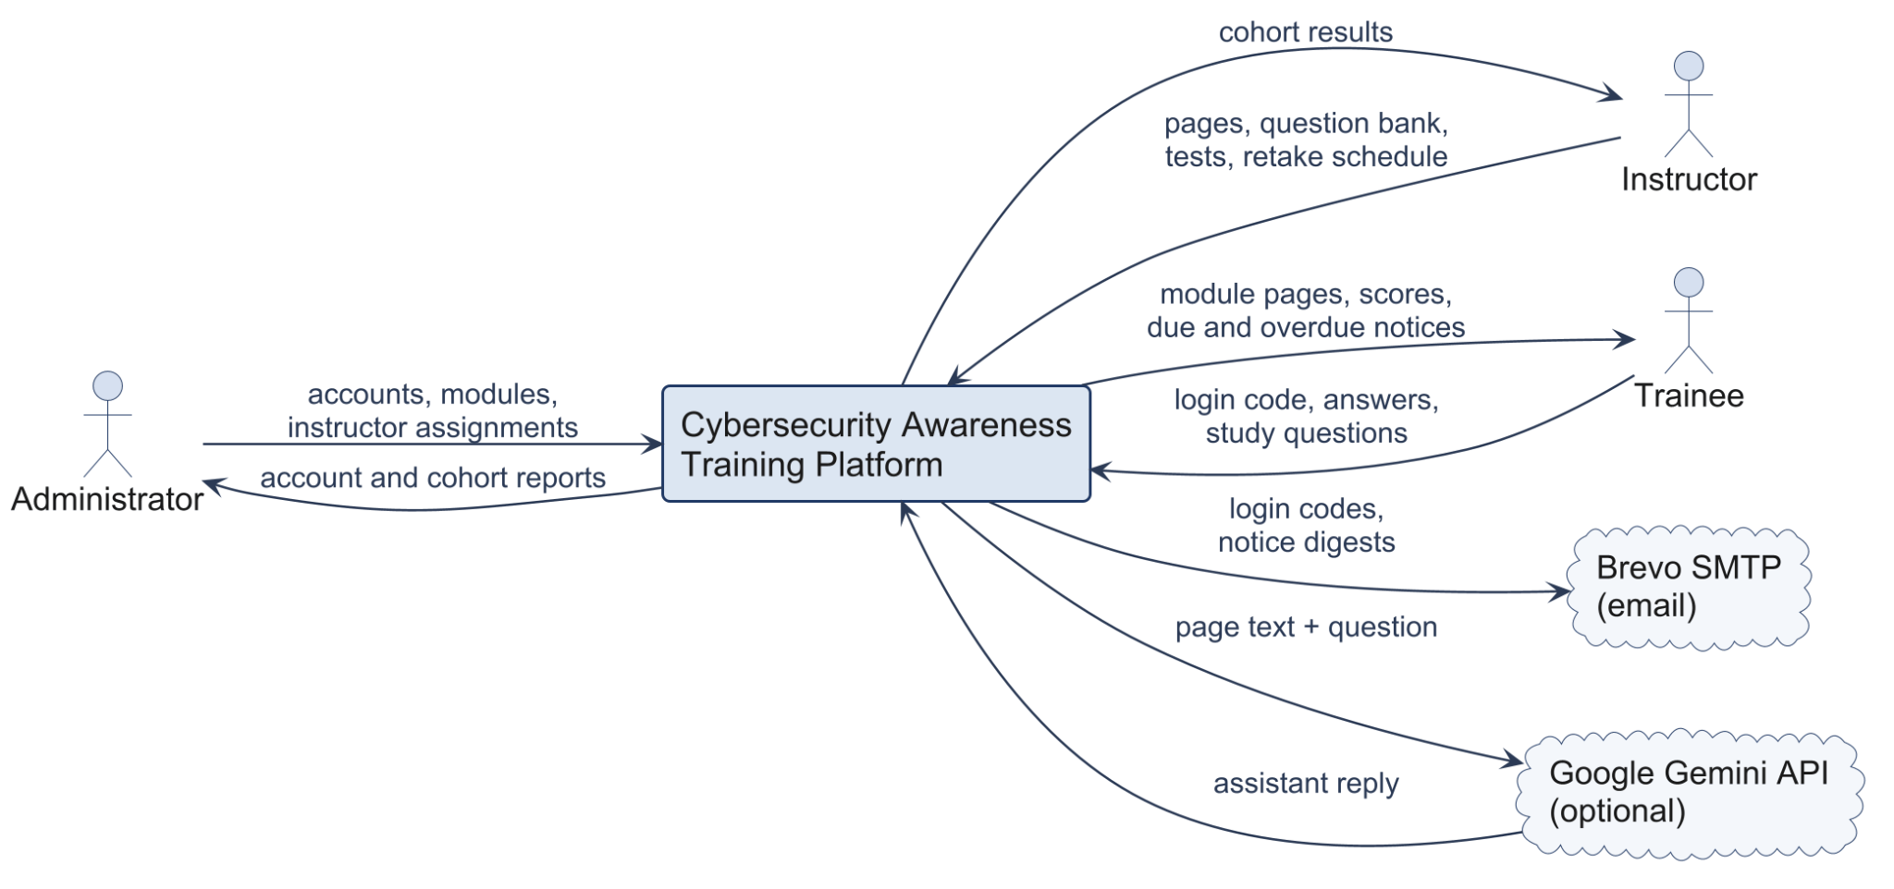

3.2 Layers
The platform is a three-tiered (browser, application, database) server-rendered application, and the application is divided into four layers (Figure 3). The request is passed to the router, which calls a service and renders a template. The business rules and access checks are stored in services. Models define the 13 tables in SQLModel, and the read models passed to templates and the validators for input are schemas. If the user cannot access a module, the response is 404 rather than 403, so it does not even confirm that the module exists.

Figure 3
Layered component diagram
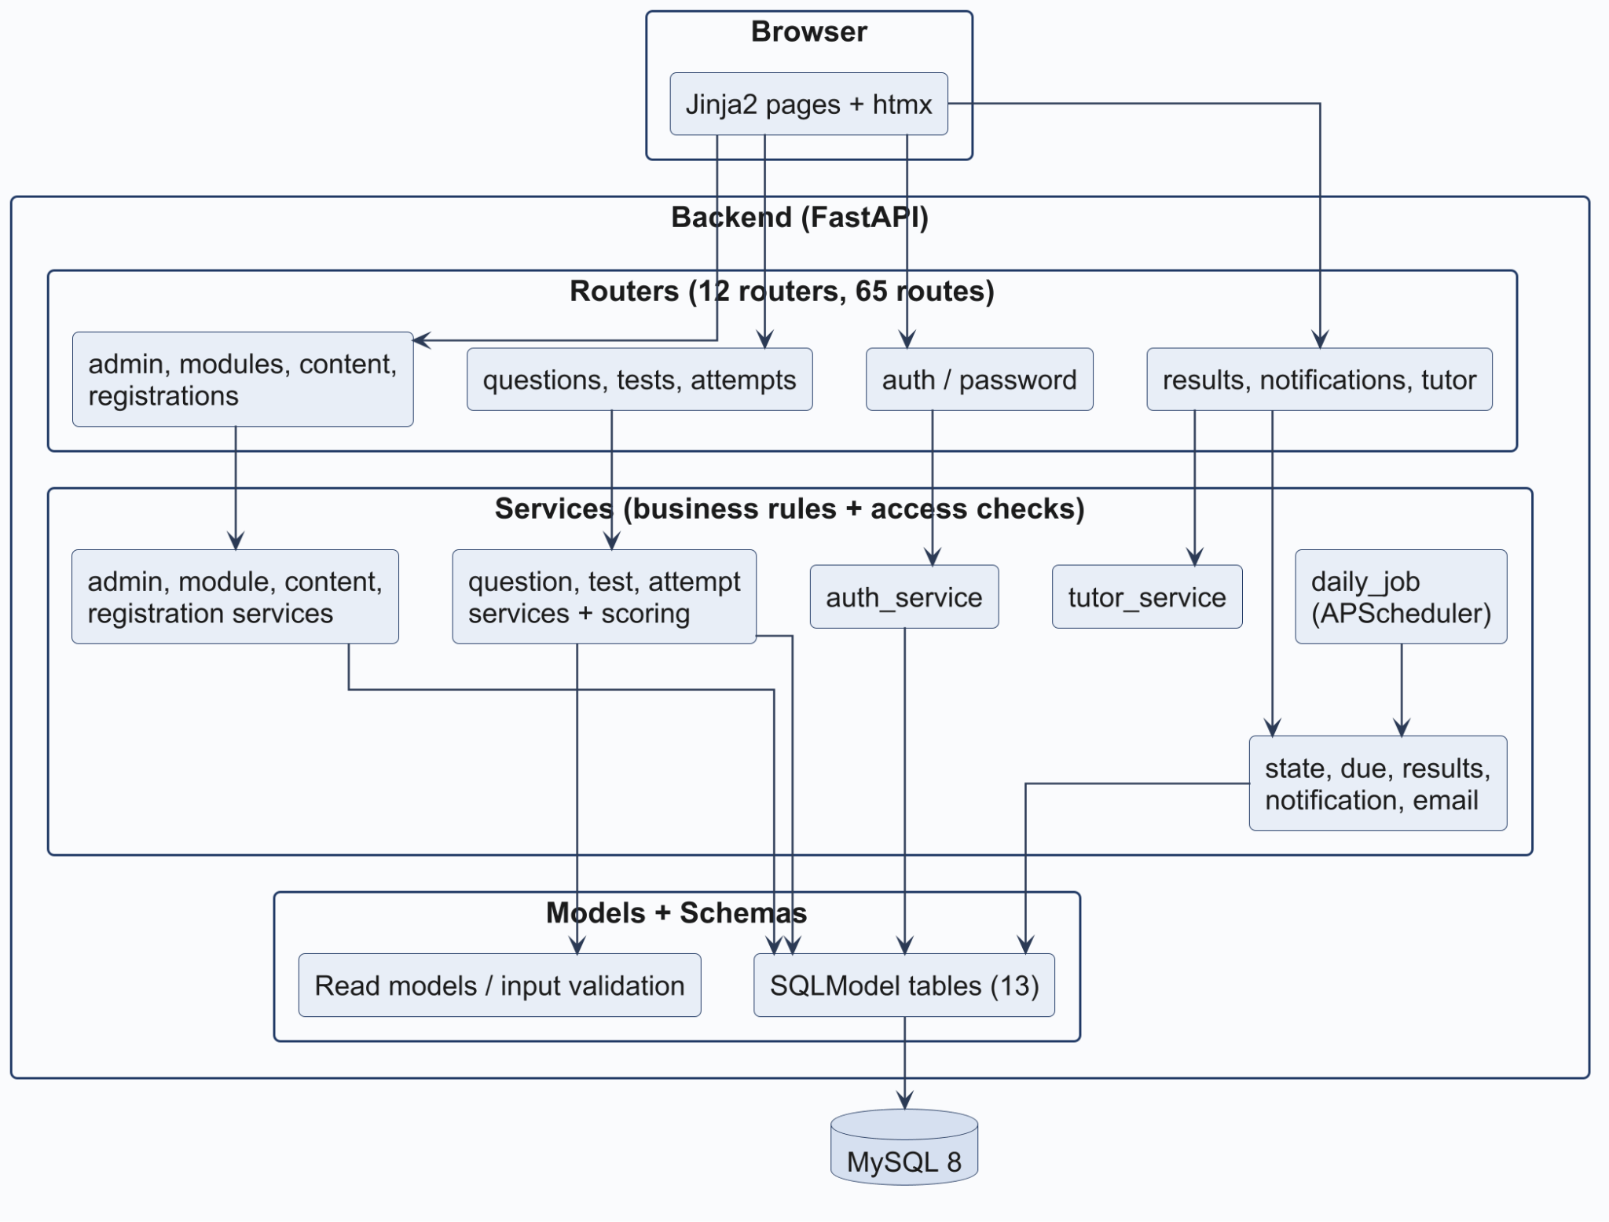

3.3 Deployment
Only nginx exposes a port (Figure 4). The backend and MySQL are accessible only within the Docker network, thus reducing the attack surface. The daily scheduler runs inside the backend process. If there are two backend replicas, the job will be executed twice. The unique constraint on notifications will prevent duplicate rows, but two processes may send the same email before either marks it as sent. That risk could be eliminated by moving the job to its own container, or by obtaining a database lock first. TLS is not configured yet; it will have to be added in production deployment at nginx.

Figure 4
Deployment diagram
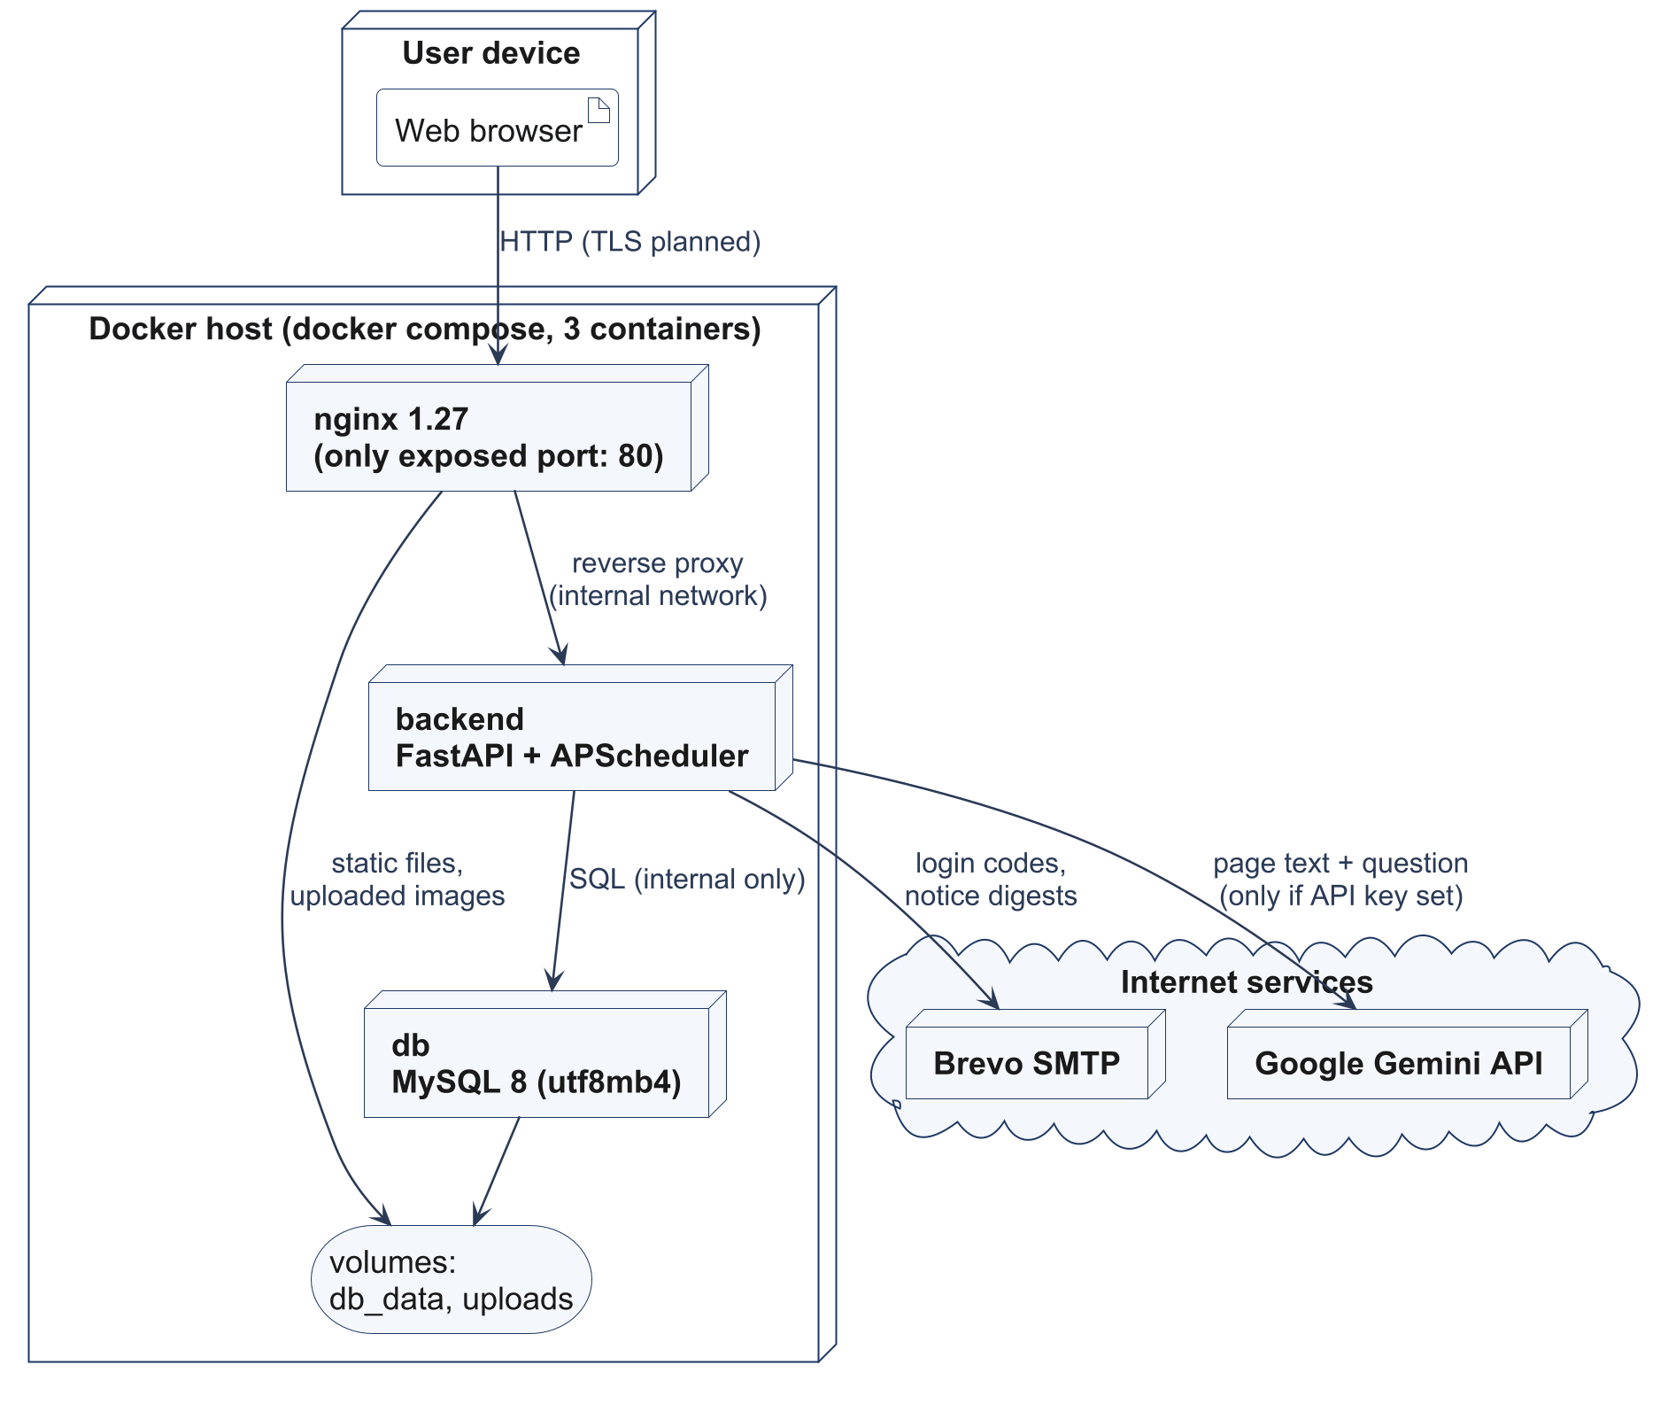

3.4 Class diagram
The domain classes are depicted in Figure 5. The centre is the module: it owns the pages, images and a question bank, and none of them makes sense without the module. The soft deletion of modules is performed using deleted_at, and hence past results can be reported.

Figure 5
Domain class diagram
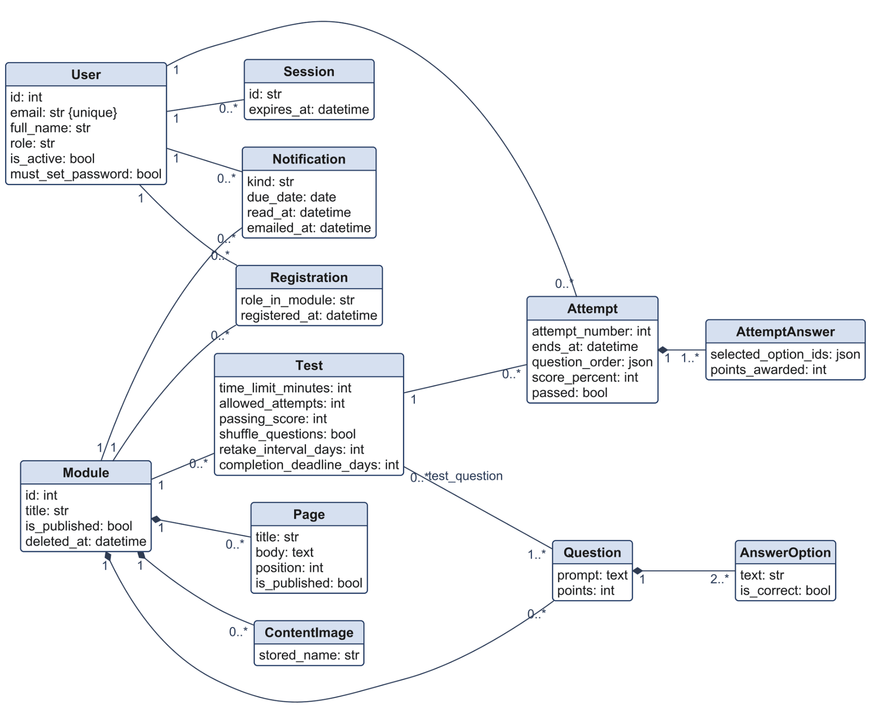

4. Data design

4.1 Entity relationship diagram
Figure 6
Entity relationship diagram (13 tables)
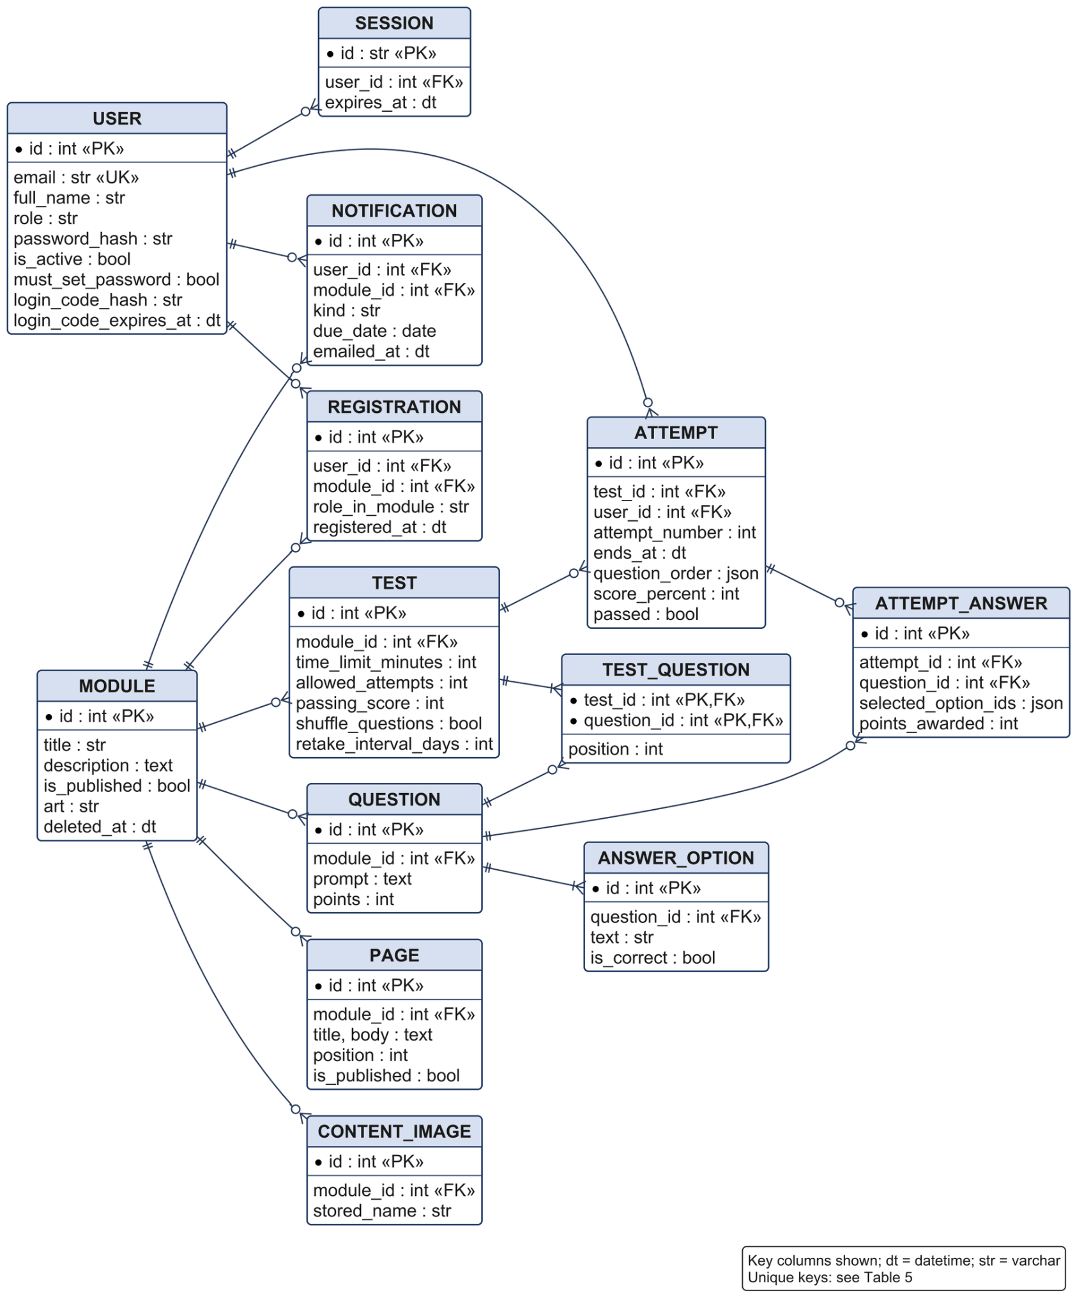

4.2 Tables and constraints
The schema has 13 tables. Critical rules are enforced by the database, because a constraint holds even if a future route forgets the check:
Table 5
Unique constraints
Table | Unique constraint | Rule it protects
user | email | One account per person
registration | (user_id, module_id) | No double enrolment
page | (module_id, position) | Stable page order
test_question | (test_id, question_id) | No repeated question
attempt_answer | (attempt_id, question_id) | One answer per question
notification | (user_id, kind, module_id, due_date) | Daily job is idempotent

4.3 Calculated values
A trainee's state, due dates, test locking and all results are calculated from attempts as needed and never stored. Over time, stored copies of derived values will differ from their source (Connolly & Begg, 2015). The cost is additional queries on each dashboard load, which is not an issue at SME scale. The bigger weakness is auditability: an SME proving that staff completed training last March needs a frozen record, and a recalculated value may differ if a pass mark changed. This can be corrected by having a completion snapshot written at each pass.
Tables are created at start-up using create_all(). This works for a prototype, but it cannot modify an existing table; a migration tool like Alembic will need to be used before the first schema change in production.

4.4 Initial content
The Table 1 modules are loaded when the app starts up from backend/app/seed_content/training_content.json. They each contain 6 pages, a 20-question bank and a quiz at the end of the module with 10 questions and a pass mark of 70% and two attempts. If there are modules that already exist, they will be skipped, which means it is safe to restart. Demo accounts are created separately using seed.py.

5. Process design

5.1 Trainee state
Each trainee has one state per module, calculated by state.py (Figure 7). The most recent attempt determines the state: with an 80% pass mark, scores of 40%, 90% and then 70% give Failed. We selected this because a refresher result should reflect what the person knows today, not a year ago. The downside is that a trainee who passes and then sits the test again casually can lose a pass; an instructor can override a score when this happens. Publishing a replacement test resets everyone to Not Started; the instructor sees how many people are affected before confirming.

Figure 7
Trainee state machine diagram for one module
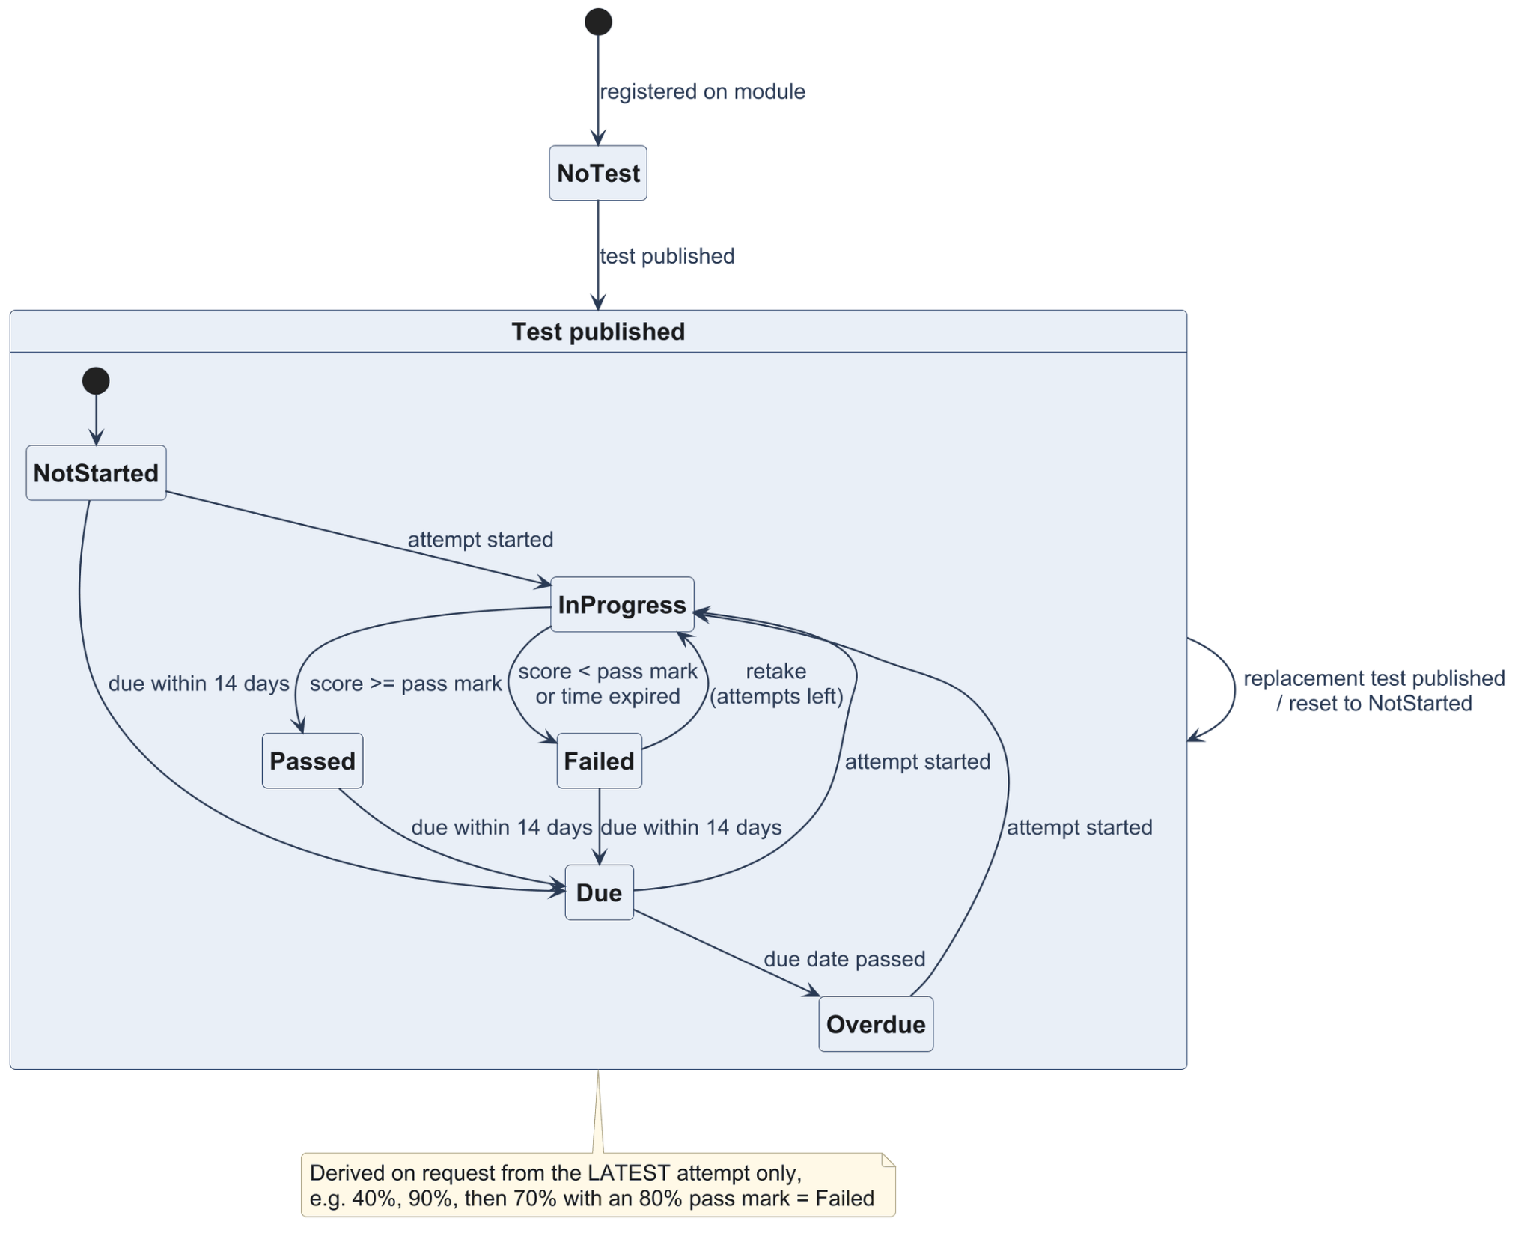

5.2 Two-step login
Once the password is compared to its Argon2 hash (Biryukov et al., 2016), a 6-digit code is sent by e-mail (Figure 8). Only hashes are stored and codes are valid only for 10 minutes, and a new code will be generated when a new login occurs. Sessions last 12 hours. According to NIST SP 800-63B, email must not be used as an out-of-band authenticator, since it indicates that someone has access to a mailbox, not that they have possession of a device (Grassi et al., 2017). If an attacker can access the trainee's mailbox then both factors are lost together. We kept email because SME staff can use it without installing anything, but an authenticator-app (TOTP) option should be provided, at least for administrators.

Figure 8
Two-step login sequence diagram
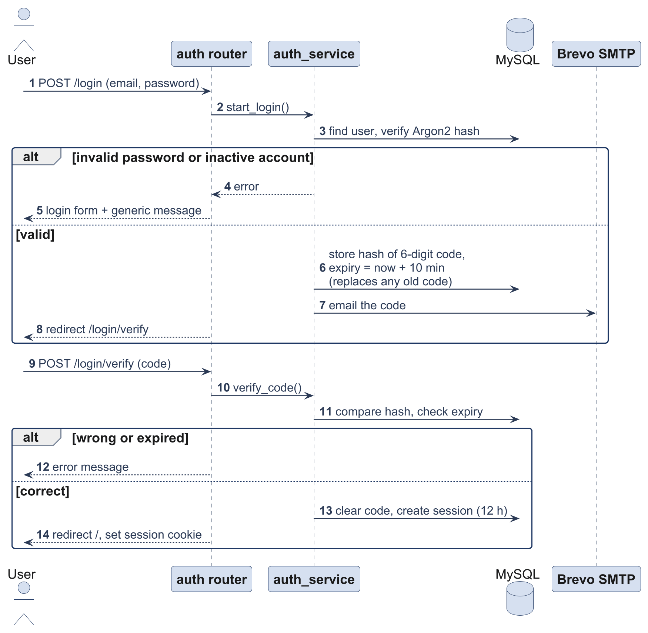

5.3 Daily job
At 06:00 UTC, the job calculates each trainee's due date, produces due-soon notices (in 14 days or less) or overdue notices and sends one digest email to each user containing all modules (Figure 9). The one email per user, not per module, is intentional because frequent reminders of security issues lead to fatigue and are ignored (Reeves et al., 2021). Emails with failed delivery have an empty emailed_at value and are retried at the next iteration.

Figure 9
Daily job sequence diagram
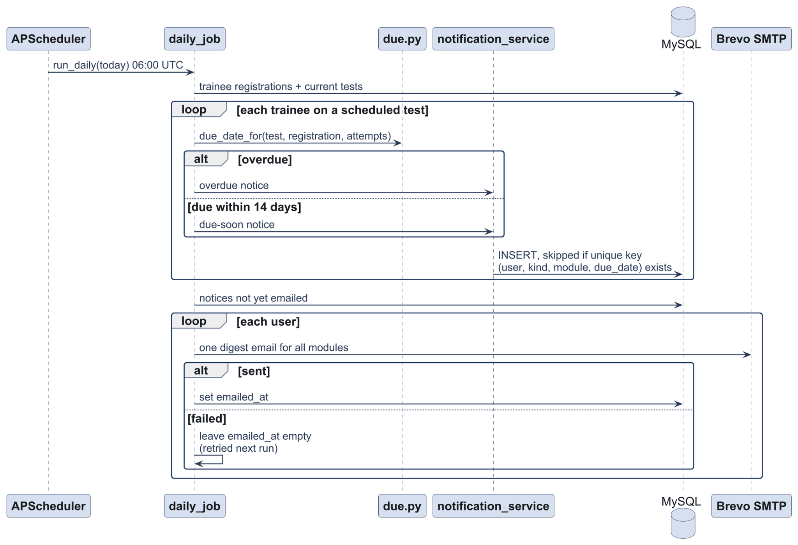

5.4 Taking a test
When the test is saved, questions are randomly selected from the bank, and if the test is saved again with the same count, the same questions will be selected again. If shuffle_questions is set to true, the order will vary each time. Answers are saved as they change, so a dropped connection loses nothing. A trainee cannot extend time by changing their clock, as the deadline (ends_at) is stored on the server. If the allowed_attempts value is set to 0, it is unlimited, and the limit is reset if the test is passed during a recurring test.

Figure 10
Taking a test activity diagram
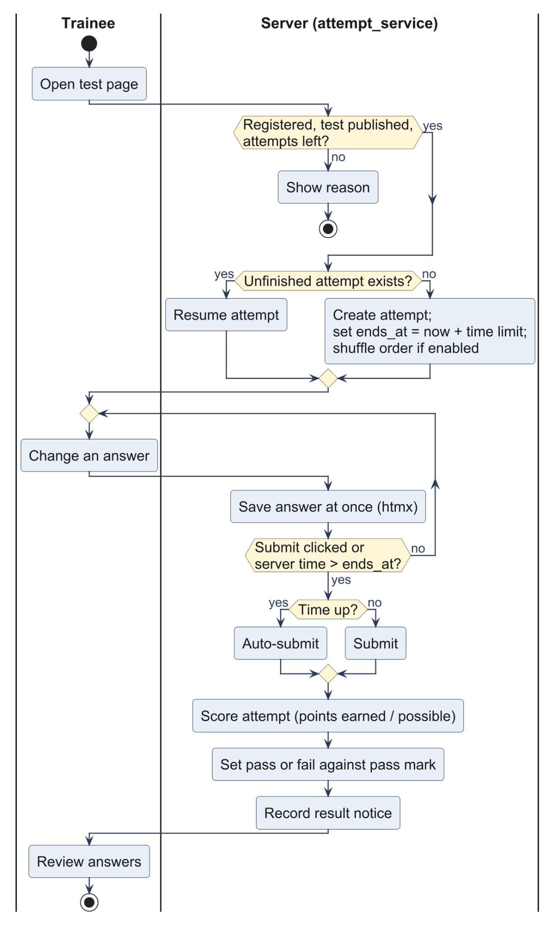

5.5 Study assistant
The assistant responds to questions about the page being read (Figure 11). Only pages the user can access are used, nothing is stored and the conversation remains in the page (last six exchanges). When there is no API key, the feature is not visible. Two risks remain. First, the page text and the trainee's question are sent to Google, which is a cross-border disclosure under APP 8 if there is personal information in the question (Office of the Australian Information Commissioner [OAIC], 2022). Second, a language model can provide a confident but incorrect response, which is important in the context of security training (Atlam, 2025). It is helpful to anchor the prompt in page text, but the assistant should show a notice and be off by default (Holmes et al., 2022).

Figure 11
Study assistant sequence diagram
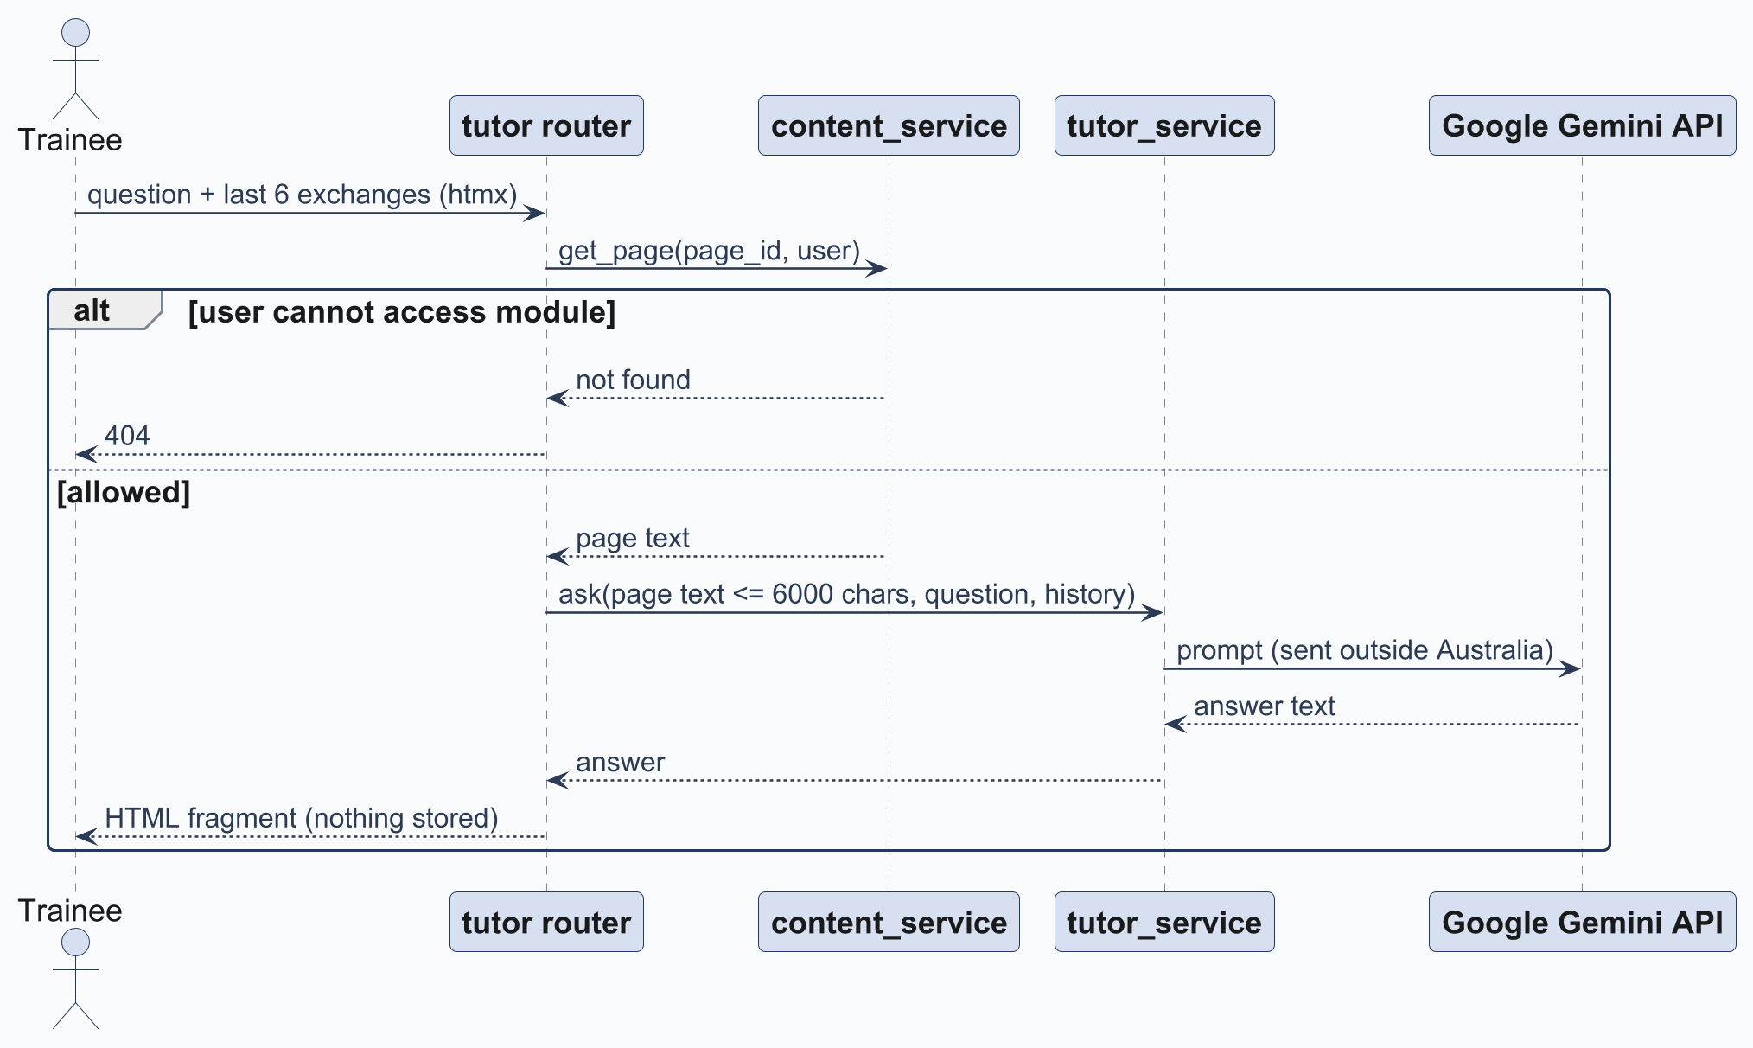

6. Interface design

6.1 Layout and components
Pages are server-rendered with Jinja2 and Bootstrap 5.3, and htmx saves test answers and runs the study assistant without full page reloading; Quill is the page editor, whose HTML is sanitized with nh3 before saving to prevent stored XSS. One stylesheet contains design tokens, and the light/dark theme follows the operating system. Staff dashboards display modules, published and draft counts; trainee dashboards display to-do, completed, overdue. Times are kept in UTC and displayed in local time.

6.2 Accessibility
Table 6
Accessibility measures
Item | Implementation | WCAG 2.2 criterion
Text contrast | At least 4.5:1 | 1.4.3 (AA)
Focus | Visible outline | 2.4.7 (AA)
Touch targets | 44px minimum | 2.5.5 (AAA, above AA)
State badges | Always have a text label | 1.4.1 (A)
Reduced motion | Transitions off when requested | 2.3.3 (AAA)
Text size | All sizes in rem | 1.4.4 (AA)
These are design claims; without screen-reader testing, conformance cannot yet be stated.

7. Implementation

7.1 Technology
Table 7
Technology choices
Component | Choice
Language and framework | Python 3.12, FastAPI, Jinja2
Data | SQLModel, MySQL 8 (utf8mb4)
Web server | nginx 1.27
Front end | Bootstrap 5.3, Bootstrap Icons, Inter, htmx, Quill
Security | Argon2 hashing, nh3 sanitising, CSRF tokens
Background and email | APScheduler, Brevo SMTP
Study assistant | Google Gemini (optional)
A server-rendered stack avoids a separate front-end build and keeps every access check on the server.

7.2 Code structure
Table 8
Code structure
Folder | Contents
backend/app/models/ | 13 tables
backend/app/schemas/ | Read and input models
backend/app/services/ | 16 service modules
backend/app/routers/ | 12 routers, 65 routes
backend/app/templates/ | 35 page templates, 4 email templates
Shared modules include config.py (settings from .env), security.py (hashing, CSRF, rate limiting) and dependencies.py (login and role checks).

8. Testing

8.1 Strategy
There are 659 automated tests in 57 files, which are executed with pytest on a different test database using MySQL 8. We test against MySQL and not SQLite to ensure that unique constraints and date handling function as they do in production. Each test will be executed in a rollback transaction, meaning that tests cannot affect one another.
Table 9
Test types
Type | Covers
Unit | Scoring, state, due dates, cover art
Service | Access checks, test locking, daily job, notifications
Route | Status codes, role access, CSRF, page content
Structure | Routers contain no queries; templates receive only read models

8.2 Traceability
Table 10
Requirement traceability
Requirement | Verified by
FR2, FR4 | Route tests on login and role access
FR5 | Service access checks and role-access route tests
FR6, FR7 | Service tests on test locking and expired attempts
FR8, FR9, FR10 | Unit tests on state.py and due.py
FR11 | Service tests on the daily job and notifications

8.3 Limitations and next steps
The tests are conducted to demonstrate that the software performs as we specified and not that it changes staff behaviour. In real organisations, studies on phishing found that quiz scores and click rates often move independently of one another (Lain et al., 2022; Marshall et al., 2024). The platform has to have a pilot in a real SME with simulated-phishing results before and after training in order to claim to reduce risk. We also have no load test, no accessibility audit with assistive technology, and no measured code coverage figure. These come next, along with TOTP, completion snapshots and migrations.

References
Atlam, H. F. (2025). LLMs in cyber security: Bridging practice and education. Big Data and Cognitive Computing, 9(7), Article 184. https://doi.org/10.3390/bdcc9070184
Australian Cyber Security Centre. (n.d.). Phishing. Australian Signals Directorate. https://www.cyber.gov.au/threats/types-threats/phishing
Australian Signals Directorate. (n.d.). Essential Eight. https://www.cyber.gov.au/business-government/asds-cyber-security-frameworks/essential-eight
Australian Signals Directorate. (2025). Annual cyber threat report 2024–25. https://www.cyber.gov.au/about-us/view-all-content/reports-and-statistics/annual-cyber-threat-report-2024-2025
Biryukov, A., Dinu, D., & Khovratovich, D. (2016). Argon2: New generation of memory-hard functions for password hashing and other applications. In 2016 IEEE European Symposium on Security and Privacy (EuroS&P) (pp. 292–302). IEEE. https://doi.org/10.1109/EuroSP.2016.31
Connolly, T., & Begg, C. (2015). Database systems: A practical approach to design, implementation, and management (6th ed.). Pearson.
Dennis, A., Wixom, B. H., & Tegarden, D. (2015). Systems analysis and design: An object-oriented approach with UML (5th ed.). Wiley.
Grassi, P. A., Fenton, J. L., Newton, E. M., Perlner, R. A., Regenscheid, A. R., Burr, W. E., Richer, J. P., Lefkovitz, N. B., Danker, J. M., Choong, Y.-Y., Greene, K. K., & Theofanos, M. F. (2017). Digital identity guidelines: Authentication and lifecycle management (NIST Special Publication 800-63B). National Institute of Standards and Technology. https://doi.org/10.6028/NIST.SP.800-63b
Holmes, W., Porayska-Pomsta, K., Holstein, K., Sutherland, E., Baker, T., Buckingham Shum, S., Santos, O. C., Rodrigo, M. T., Cukurova, M., Bittencourt, I. I., & Koedinger, K. R. (2022). Ethics of AI in education: Towards a community-wide framework. International Journal of Artificial Intelligence in Education, 32(3), 504–526. https://doi.org/10.1007/s40593-021-00239-1
International Organization for Standardization. (2022). Information security, cybersecurity and privacy protection: Information security controls (ISO/IEC 27002:2022). https://www.iso.org/standard/75652.html
Lain, D., Kostiainen, K., & Čapkun, S. (2022). Phishing in organizations: Findings from a large-scale and long-term study. In 2022 IEEE Symposium on Security and Privacy (SP) (pp. 842–859). IEEE. https://doi.org/10.1109/SP46214.2022.9833766
Marshall, N., Sturman, D., & Auton, J. C. (2024). Exploring the evidence for email phishing training: A scoping review. Computers & Security, 139, Article 103695. https://doi.org/10.1016/j.cose.2023.103695
National Institute of Standards and Technology. (2024a). Building a cybersecurity and privacy learning program (NIST Special Publication 800-50 Rev. 1). U.S. Department of Commerce. https://doi.org/10.6028/NIST.SP.800-50r1
National Institute of Standards and Technology. (2024b). The NIST Cybersecurity Framework (CSF) 2.0 (NIST CSWP 29). U.S. Department of Commerce. https://doi.org/10.6028/NIST.CSWP.29
Office of the Australian Information Commissioner. (2022). Chapter 8: APP 8 Cross-border disclosure of personal information. In Australian Privacy Principles guidelines. https://www.oaic.gov.au/privacy/australian-privacy-principles/australian-privacy-principles-guidelines/chapter-8-app-8-cross-border-disclosure-of-personal-information
OWASP Foundation. (2021). OWASP Top 10:2021. https://owasp.org/Top10/
Prümmer, J., van Steen, T., & van den Berg, B. (2024). A systematic review of current cybersecurity training methods. Computers & Security, 136, Article 103585. https://doi.org/10.1016/j.cose.2023.103585
Reeves, A., Delfabbro, P., & Calic, D. (2021). Encouraging employee engagement with cybersecurity: How to tackle cyber fatigue. SAGE Open, 11(1). https://doi.org/10.1177/21582440211000049
Royce, W. W. (1970). Managing the development of large software systems. Proceedings of IEEE WESCON, 26, 1–9.
Sommerville, I. (2016). Software engineering (10th ed.). Pearson.
World Wide Web Consortium. (2023). Web content accessibility guidelines (WCAG) 2.2. https://www.w3.org/TR/WCAG22/

